**String, String Buffer & String Builder**

* **String**

1. **Determine length of string**

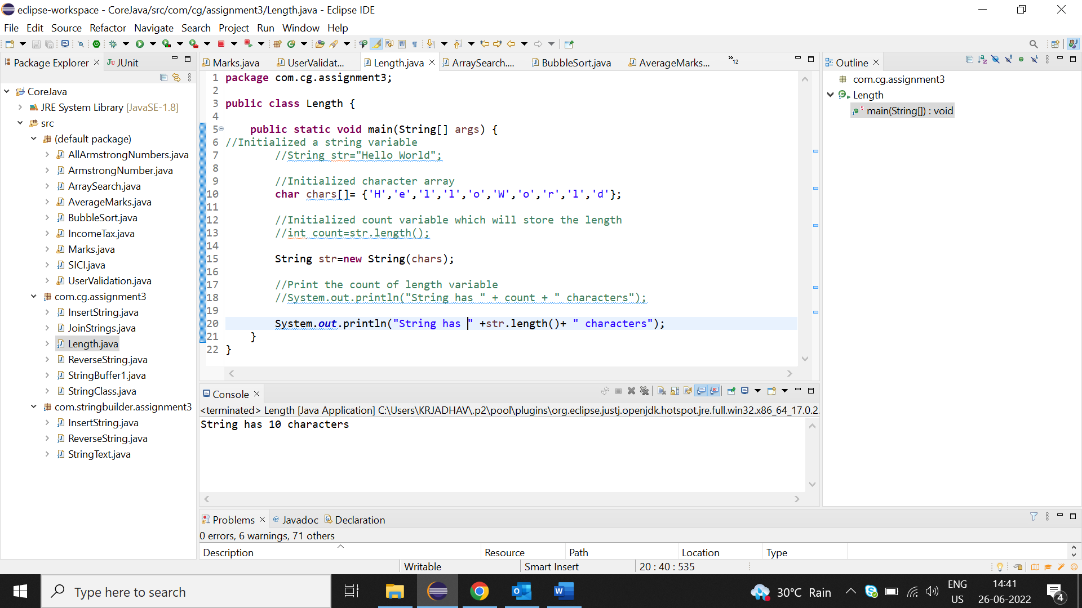

**2.Join two strings**

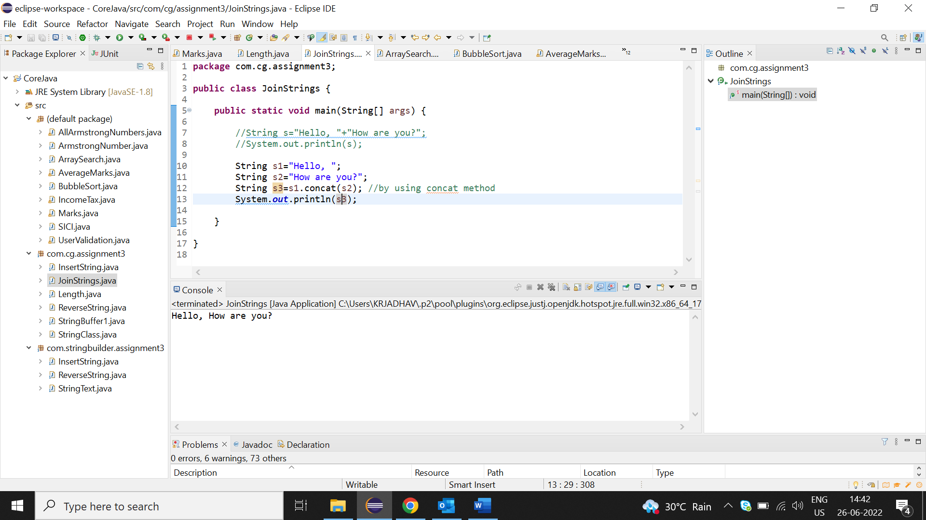

**3.Perform various string operation(uppercase, lowercase, replace, add,check)**

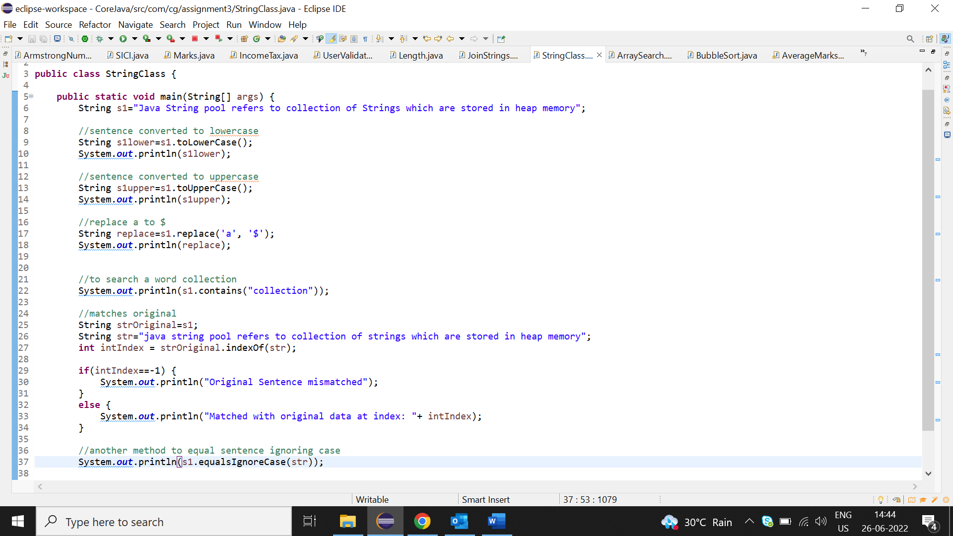

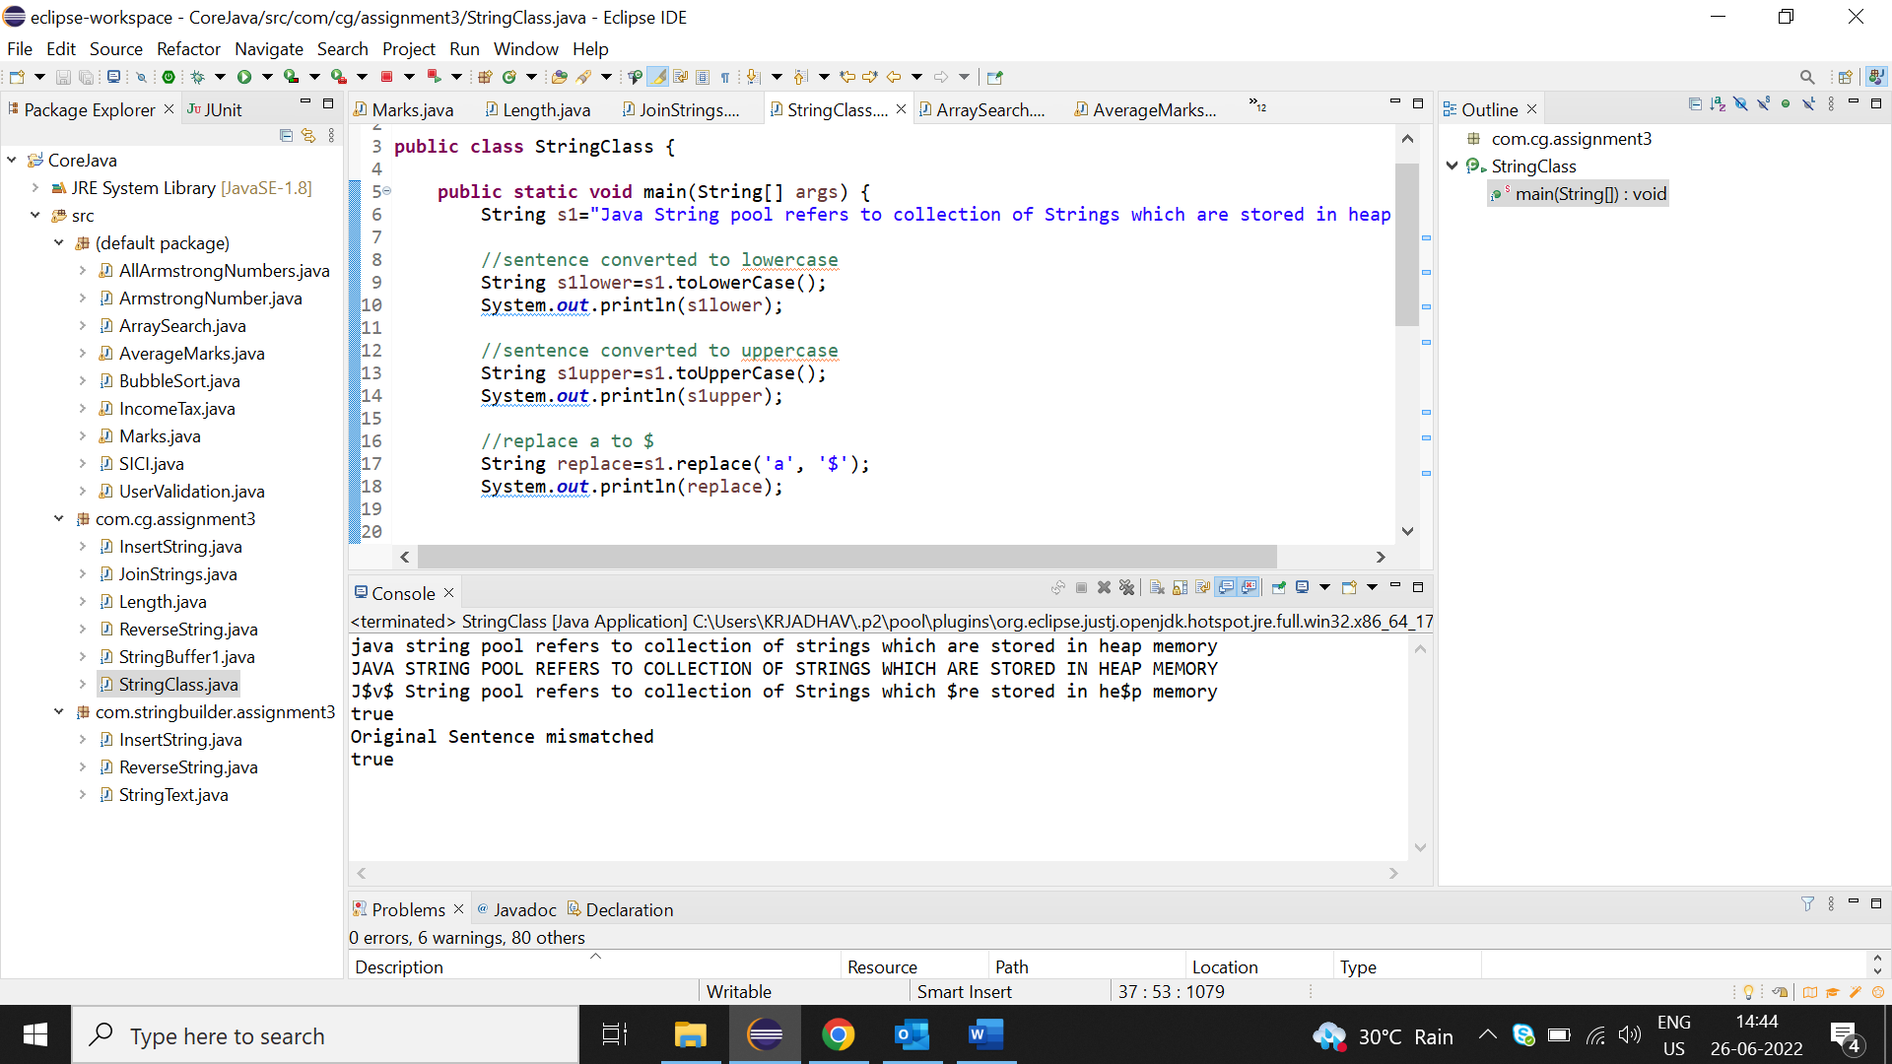

* **Assignments on String Buffer**

**1.Append the statement**

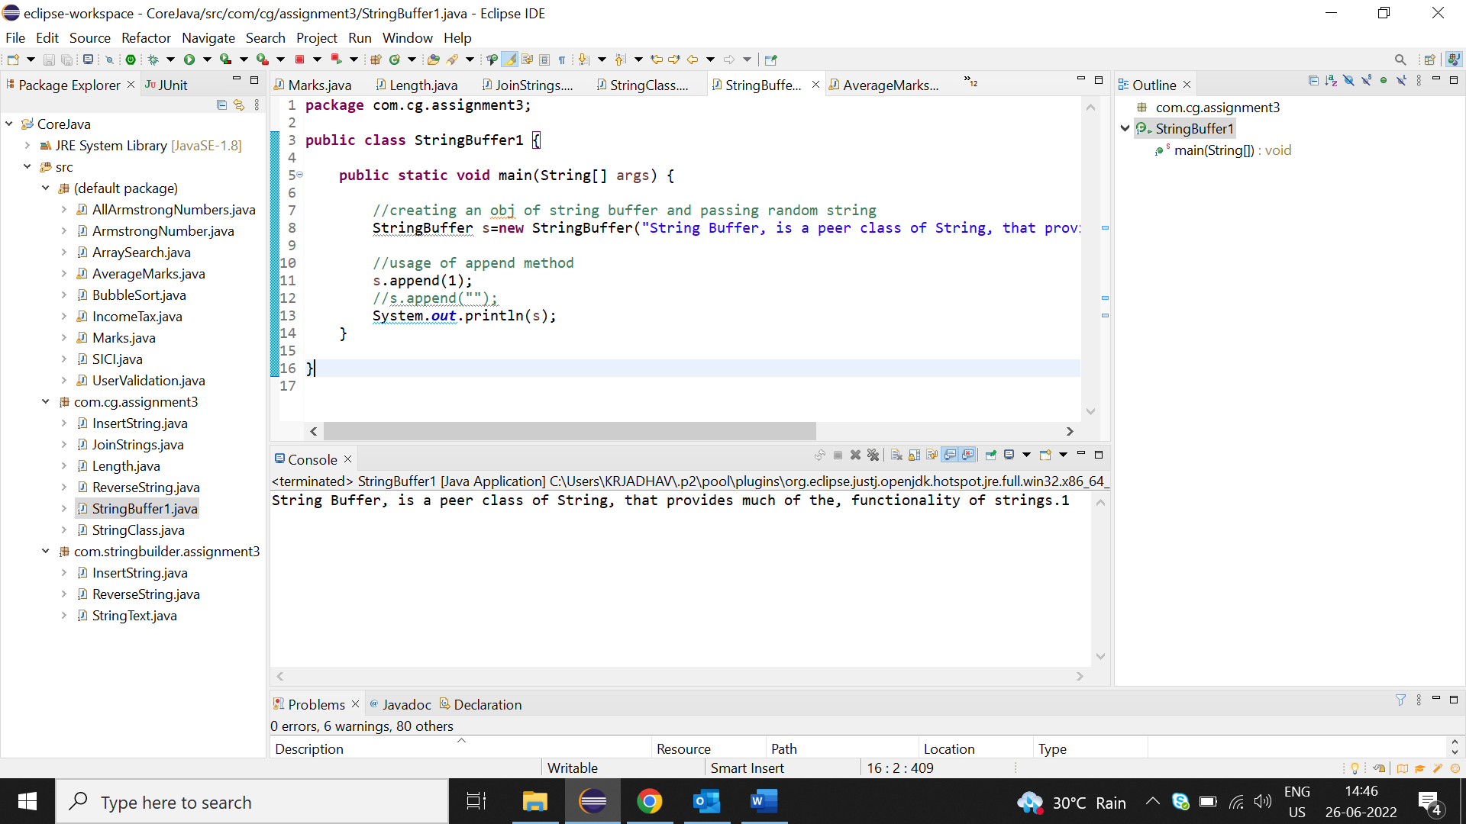

**2.Fill the blank space at output with provided input**

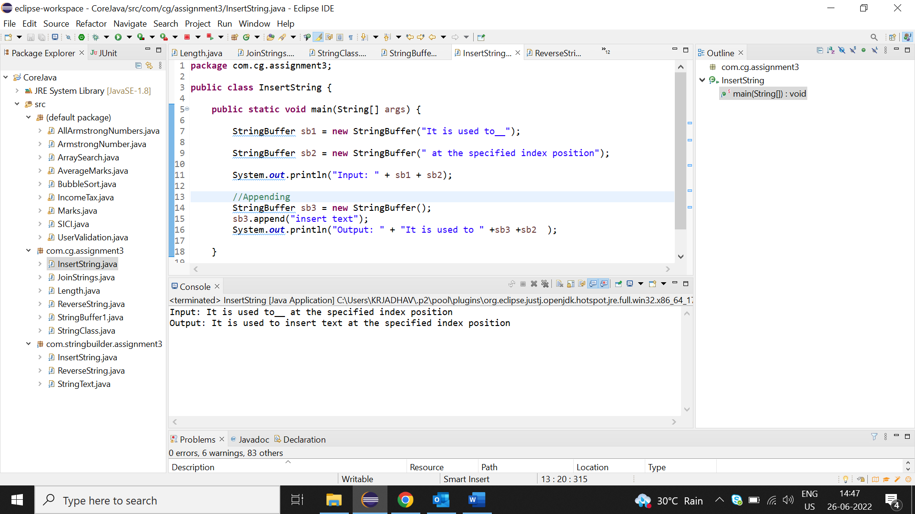

**3.Reverse given string**

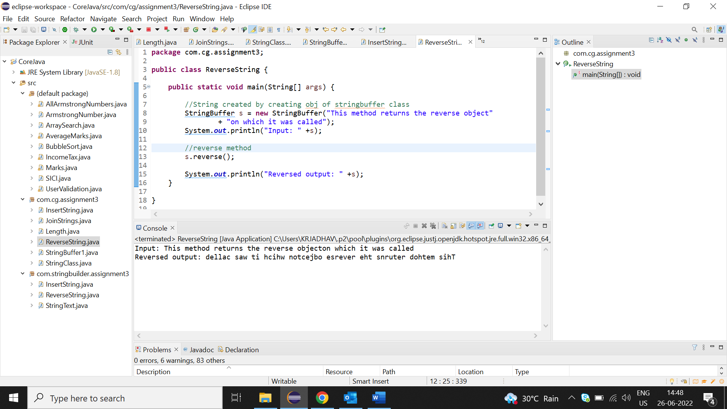

* **Provide solutions for assignments on stringBuffer using StringBuilder**

